**Steps to sync ADLS gen 2 to ADLA**

Log in to Azure Portal

Choose the ADLS gen 2 you want to use

Required info from the ADLS gen 2

1. Storage name ex. dyadlsg2
2. Left side panel Setting > Access keys (we will need this Key1 later)

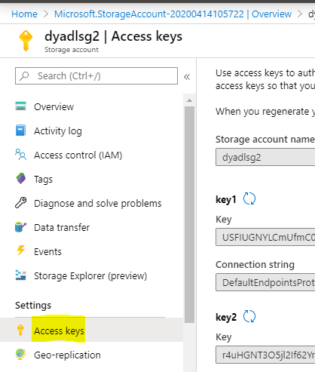

Now go to your ADLA

On the left panel >Data Lake Analytics > Data explorer > Add data resource

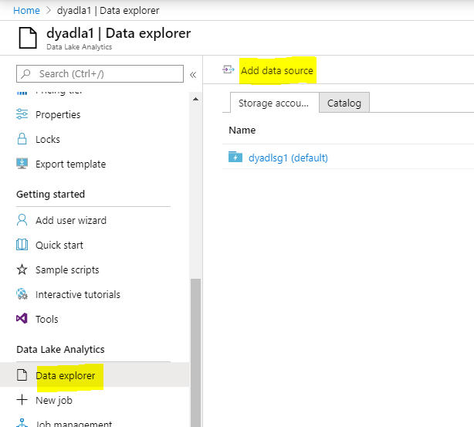

A pop-up window will prompt, and you will need to fill out the info you got from ADLS gen2

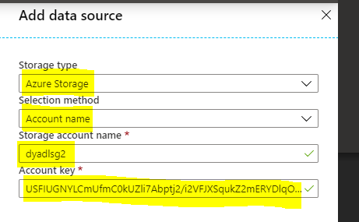

Click add, you should be done with the sync at this point.